Library Management System Documentation

Problem Definition

* Libraries often face challenges in managing various resources such as books, stationery, DVDs, and CDs. A lack of efficient resource management leads to errors, delays, and customer dissatisfaction. Our system addresses these issues by providing a streamlined and modular approach using microservices.

Scope

* The system is designed for libraries to manage their resources efficiently. It includes user authentication, book management, stationery inventory, and DVD/CD tracking. The use of microservices architecture ensures scalability and flexibility.

Services

* The system comprises the following microservices:

1. Authentication Service: Handles user signup and login.
2. Books Service: Manages book inventory and transactions.
3. Stationery Service: Handles the inventory of stationery items.
4. DVDs and CDs Service: Tracks and manages DVDs and CDs.

API URLs

1. Authentication Service:  
 - Signup: POST /auth/signup  
 - Login: POST /auth/login  
2. Books Service:  
 - Get Books: GET /book  
 - Add Book: POST /book  
3. Stationery Service:  
 - Get Stationery: GET /stationery  
 - Add Stationery: POST /stationery  
4. DVDs and CDs Service:  
 - Get DVDs/CDs: GET /media  
 - Add DVD/CD: POST /media

Database

The System uses MongoDB: same clusters with different collections for each microservice

Testing

* Authentication
* 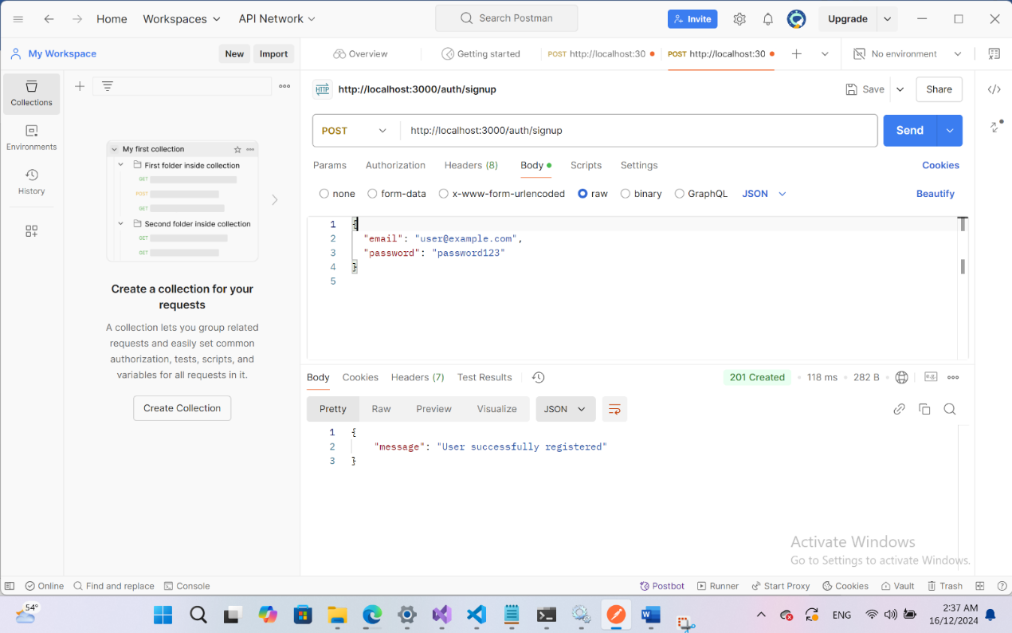

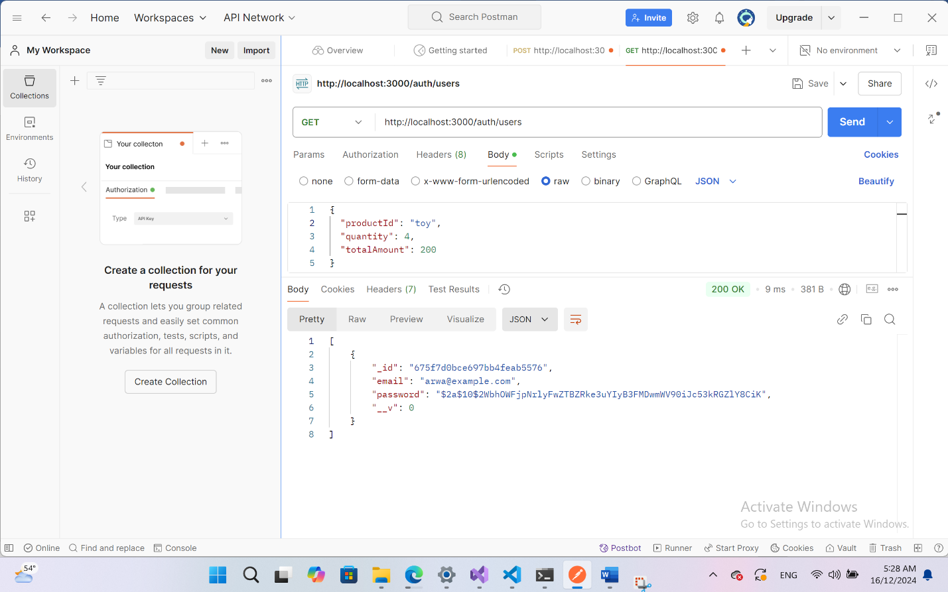

* Books
* 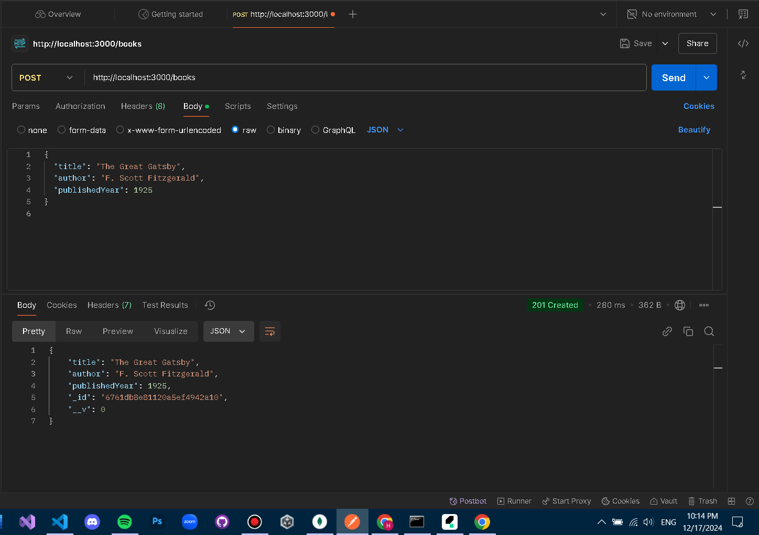
* 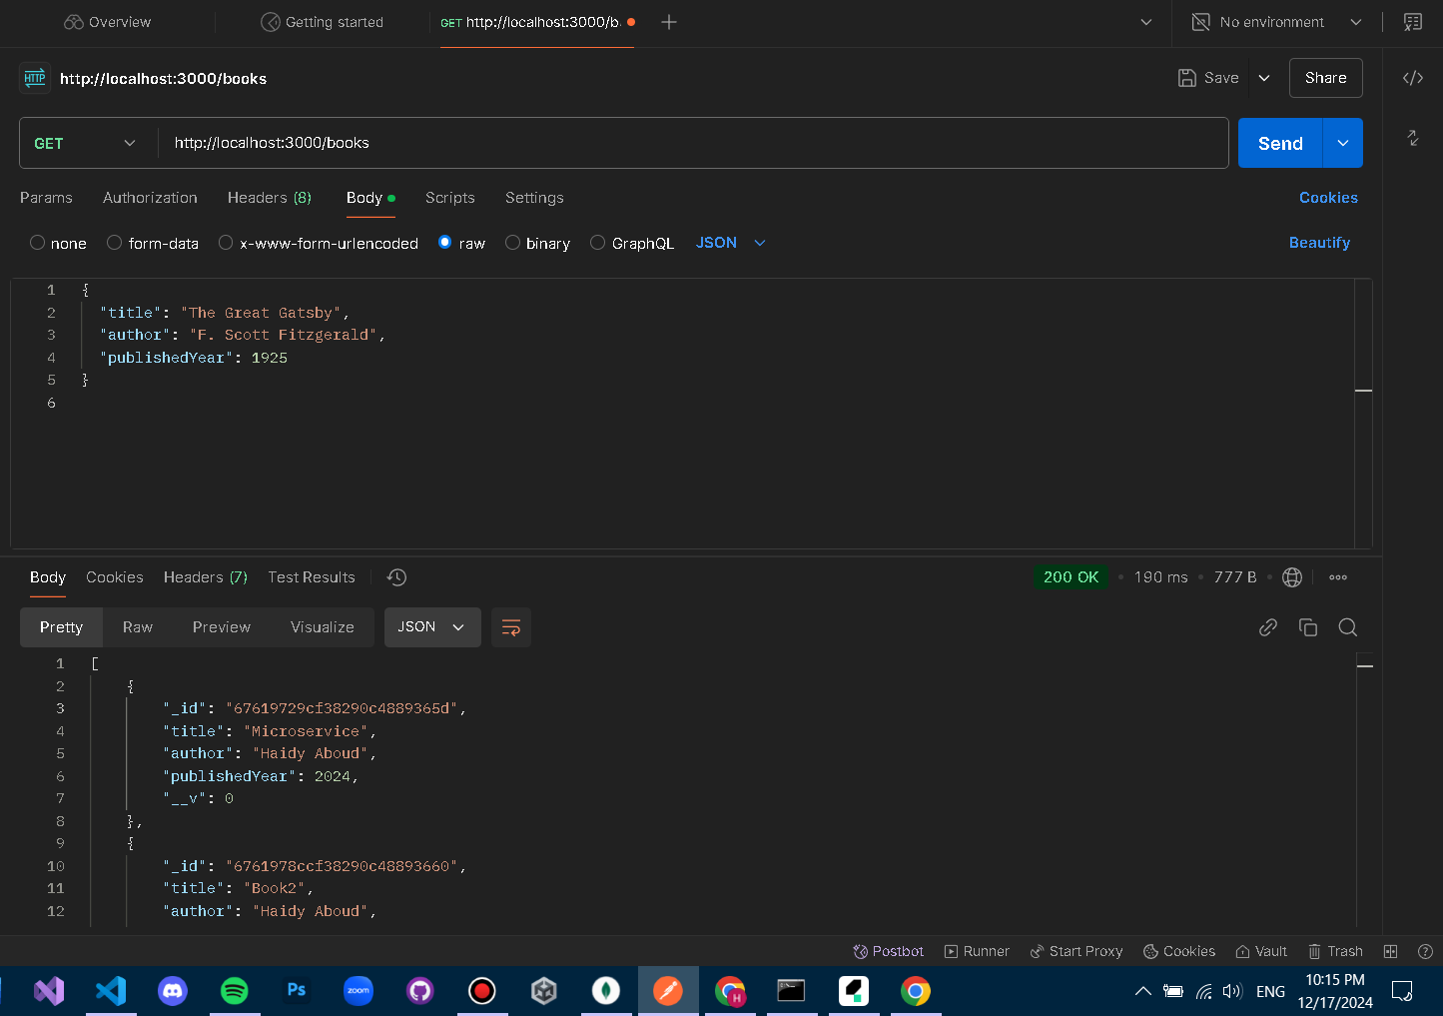
* Stationery
* 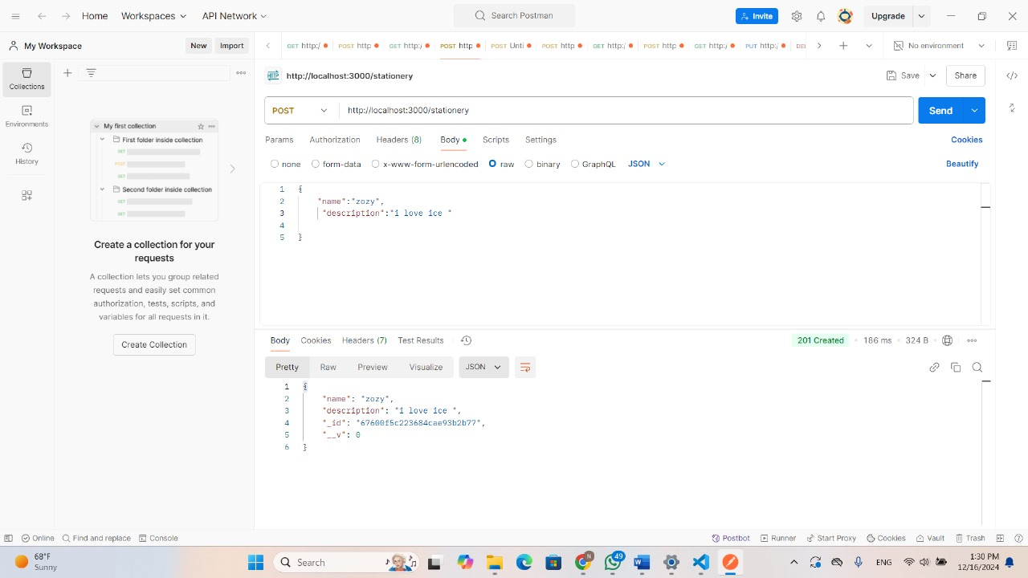
* 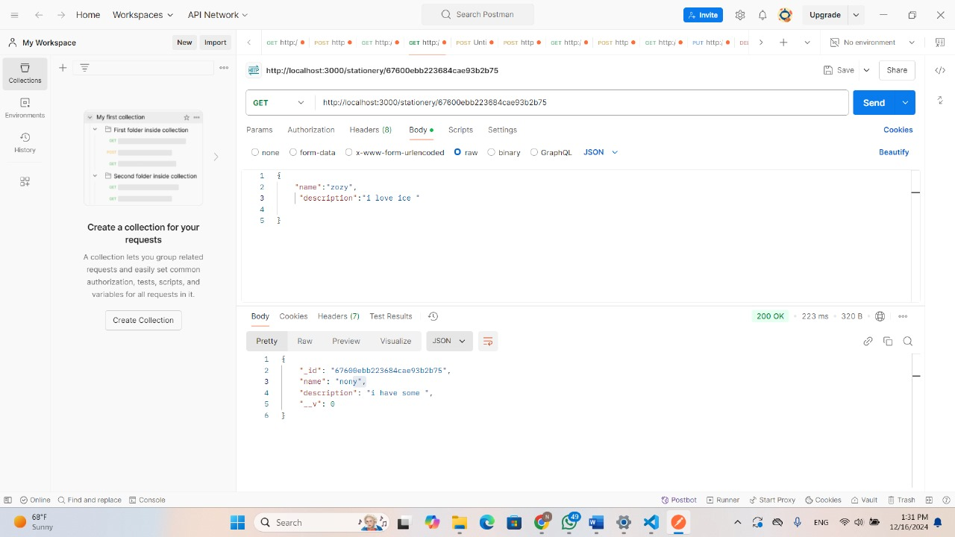
* Media

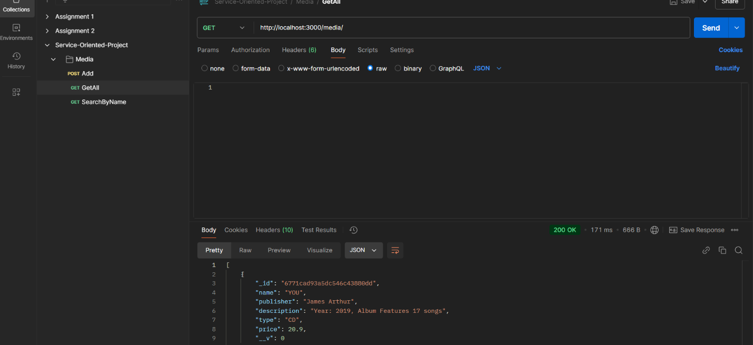

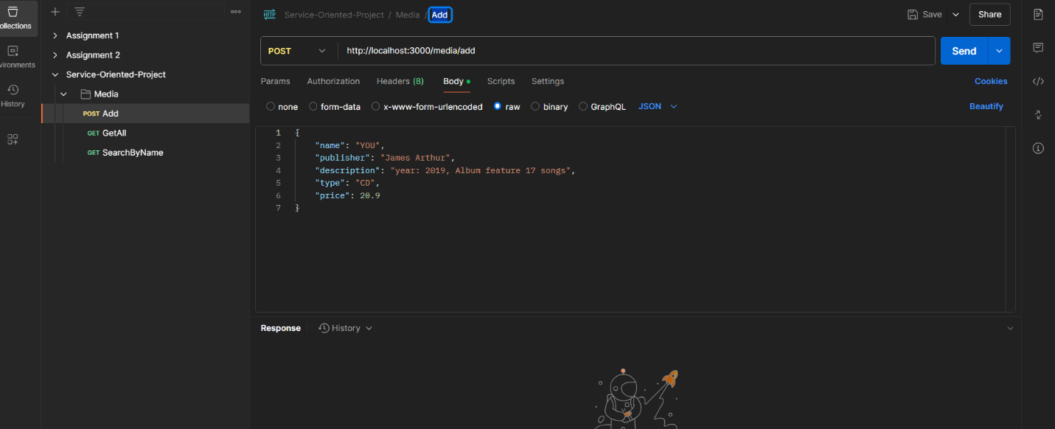

GitHub Link

[Ahmed-Wael-Adel/Service-Oriented-Project](https://github.com/Ahmed-Wael-Adel/Service-Oriented-Project)

Tools and Technologies

1. Backend: NestJS  
2. Frontend: React.js  
3. Databases: MongoDB  
4. Tools:Postman